

|  |  |
| --- | --- |
| **Student Name/ID Number:** | Syukur Sidiq Nur Alam / BDSE07-0922-089 |
| **Academic Year:** | 2023 |
| **Unit Assessor:** | Ei Thandar Khaing |
| **Project Title:** | Power BI Data Preparation and Data Transformation |
| **Issue Date:** |  |
| **Submission Date:** |  |

|  |
| --- |
| **Learner declaration** |
| I certify that the work submitted for this assignment is my own and research sources are fully acknowledged.  Student signature: Date: 04 – 12 - 2023 |

**Assignment 3:**

Overview

In this lab, you will use some basic visualization to be done in a report to retrieve data from the COVID 19 dataset. Before starting this lab, you should view **IU3 – Power BI Data Preparation and Data Transformation.**

What You’ll Need

• COVID 19 Dataset uploaded into your workspace

• Create the Report from dataset of your workspace and save the report using naming convention as

below

• <cohortame>-<cohortno>-<learnernameasperIC>-lab2

• Eg: BADQV-1020A-AAAA-lab2

Take a screenshot of the workspace with its Dataset and report

**Task 1: Retrieve Total confirmed cases , daily deaths, daily cases as**

**number**

**Task 2: Retrieve Total confirmed cases by Month**

**Task 3: Retrieve Daily cases by Month**

**Task 4: Create Date filter**

**Task 5: Create text filter**

**Task 6: Create a table with country, state, DAILY cases, deaths, total**

**confirmed cases , total deaths**

**Task 1: Retrieve Total confirmed cases, daily deaths, daily cases as number**

Familiarize yourself with the visualizations by drag and drop the total confirmed cases that retrieves

all confirmed cases. Make the visual as CARD to get the total number. Repeat the same step for daily

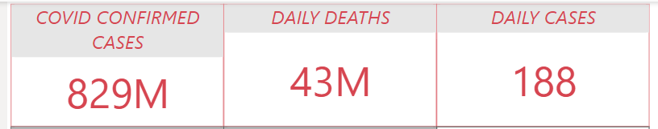

**Task 2: Retrieve Total confirmed cases by Month**

Create a LINE CHART visual of all confirmed cases by month field that includes the month, day under

AXIS and total confirmed cases under VALUES.

1. You can do your own formatting of font size, Data color, title, background

2. Make sure border is ON under formatting

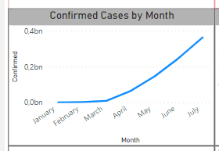

**Task 3: Retrieve Daily cases by Month**

Create a LINE CHART visual of all daily cases by month field that includes the month, day under AXIS

and daily cases under VALUES

1. You can do your own formatting of font size, Data color, title, background

2. Make sure border is ON under formatting

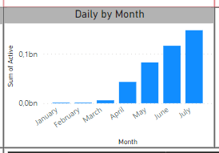

**Task 4: Create a Date filter**

Create a SLICER visual of date field AND SELECT BETWEEN from the dropdown of the visual

1. You can do your own formatting of font size, Data color, title, background

2. Make sure border is ON under formatting

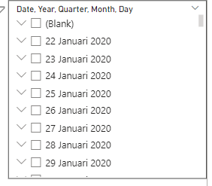

**Task 5: Create a Text filter**

Use GET MORE VISUALS From the visualisations, Search for TEXT FILTER visual. Create TEXT FILTER

visual for STATE field or COUNTRY field

1. You can do your own formatting of font size, Data color, title, background

2. Make sure border is ON under formatting

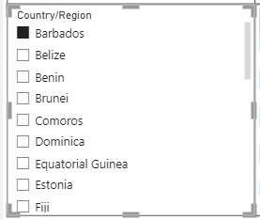

**Task 6: Create a table with country, state, DAILY cases, deaths, total confirmed cases, total deaths**

Create TABLE visual for Country,State, daily cases, deaths, total confirmed cases, total deaths

1. You can do your own formatting of font size, Data color, title, background

2. Make sure border is ON under formatting

